Operations Guide for Office Project Server 2007

Table of Contents
- Microsoft Office Project Server 2007 Queuing System

Microsoft Office Project Server 2007 Queuing System
Note This content is preliminary content for a preliminary software release. It might be incomplete and is subject to change.
In this article

- Overview
- Queuing process
- Queuing Architecture
- The Project and Timesheet queues
- Queuing Deployment
- Queue groupings
- Queuing states
- Queue Management

This article describes the Microsoft Office Project Server 2007 Queuing System which is a new, key feature in this release. The article provides an overview of the Queuing System, the queuing process and architecture, the methods in which queuing jobs are grouped, states that queuing jobs can be in, and managing queuing through the Microsoft Office Project Web Access user interface.

Overview
A queue is a waiting line that becomes a necessity when the number of service requests becomes greater than the optimum serving capacity. In an Enterprise Project Management System, there are several instances when this is true. For example:
- Before they leave for the day, nearly all 500 employees of a small company submit their timesheets at 5PM on Friday.
- A few hours before their 'Hands-On status meeting', nearly all project managers publish their projects.
The purpose of the Office Project Server 2007 Queuing System in to handle these spikes in demand gracefully and reliably. The Office Project Server 2007 Queuing System takes all the users input, records an entry for the request in SQL Server, and then processes the data asynchronously on a first-come, first-server basis. The number of jobs waiting to be processed will increase under stress, but having a queue ensures that the Office Project Server 2007 EPM solution will not stop working because of a spike in load.
Nearly all critical operations in the Office Project Server 2007 system go through the Office Project Server 2007 Queuing System. These include:
- Project Save
- Project Publish
- Timesheet Save
- Timesheet Submit
- Project Backup/Restore
- Report Data Service
- Cube Building Service
- Server Side Scheduling (and node-consistency processing)
Project Queuing System provides the following advantages:
- Reliability
  - Data integrity: There is a well-defined protocol to save any job in the queue. If a job is just half-saved, it is never processed. Also, all jobs are saved into SQL Server (not the file system) and take advantage of SQL transactions.
  - In-order delivery: If a Project Professional user clicks Save and then Publish, we ensure that the Save job gets processed first, and then Published.
  - Fault tolerance: Failed jobs in the queue can be retried. Also, if you have more than one Queue Processing Service running, if one of them crashes or stops, the other one will pick up the extra load seamlessly (transparent failover).
- Scalability
  - Multi-threading: The Office Project Server 2007 Queueing System can process multiple jobs at the same time. For example, Project 1 Save, Project 2 Publish and a CubeBuilding job can be processed simultaneously.
  - Customers can simply add more Project middle-tier servers if they want to handle load better. Each middle-tier server will have a Project Queueing Service and they will share the load automatically.
  - The number of jobs in the queue is only limited by the scale limitations of SQL Server.
- Manageability
  - Manage Queue UI is provided as part of Project Web Access to manage all jobs in the queue (Administrators can see all the jobs in the queue, cancel, or retry jobs using this interface).
  - My Jobs UI is provided as part of Project Web Access to manage one's own jobs (self service).
  - Queue Settings UI is provided as part of Project Web Access to set or change any property of the Office Project Server 2007 Queuing System. All these properties can be set at the Project instance level.
  - Extensive diagnostic information to help with troubleshooting (detailed NT Event log, Trace log entries).
  - Queue performance counters to enable performance tuning.
?Top of Page

Queuing process
The following illustration describes the queuing process:
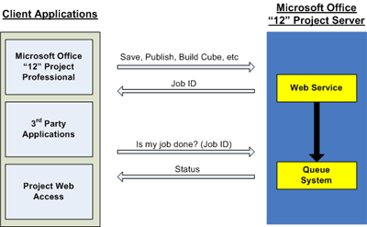
- User makes a request from a client application (for example, Publishing a Project from Project Professional).
- The Project Web service takes the request and puts it in the queue.
- A Job ID is issued back to the user.
- The user queries to check the status of the request through the issued Job ID.
- The Office Project Server 2007 Queuing System returns the status of the request to the user.
?Top of Page

Queuing Architecture
The Project Server Queuing Service logical architecture is comprised of the following four modules:
- Job Storage
- Job Polling
- Job Processing
- Job Status Check and Management
When requests are made of the Project Server Queuing Service, such as adding or processing jobs or retrieving status, these modules work as a whole to fulfill the required task. This section describes this process in detail.

Queuing Modules
The Project Server Queuing System is composed of the following modules:
- Job Storage: Queue jobs are stored in the Draft and Published Project Server databases. In this manner, the jobs are backed up and restored as part of the normal Project Server database backup and restore routines.
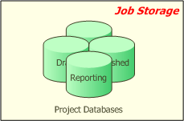
- Job Polling: Job storage is polled at regular intervals by a Job Polling thread to check for new jobs. Polling intervals are configurable by administrators in the Manage Queue UI.
  - The Job Polling Thread is started inside the Queueing NT service – which is installed on every Project Server Middle Tier machine as part of provisioning. Job polling threads reside within the Queueing NT service process space and run under the Queueing NT service identity.
  - The Job Polling Thread has two main properties:
Type – A given job polling thread could be a ‘project job polling thread’ (looking for project related jobs) or a ‘timesheet job polling thread’ (looking for timesheet related jobs).
Project Web Access instance – Every job polling thread looks for jobs originating from a specific Project Web Access instance.
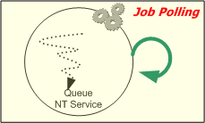
- Job processing: If the Job Polling Thread finds new jobs, it spawns one ‘Job Processing Thread’ per job to process the job. The maximum number of Job Processor threads is configurable by administrators. Note that the job processing threads reside within the “Queuing NT Service” process space and run under the “Queueing NT service” identity.
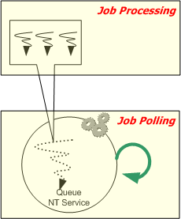
- Job Status Check and Management: This is the end-user facing module of the Project Server Queue.
  - Manage Queue UI: Administrators use this to see the status of any job in the queue. They can also ‘Cancel’ or ‘Retry’ failed jobs. This is part of PWA – no need to download any special tool.
  - Queue Settings UI: Administrators can view/change the settings of queue like polling interval and the maximum number of job processor threads. This is part of PWA – no need to download any special tool.
  - My Jobs UI: Any user can check the status of their jobs using this interface. This is part of PWA – no need to download any special tool.
  - Queue Status PSI: Software Developers can use these PSIs to get the status of any Queue Job. There are a number of powerful filters to narrow down the search.
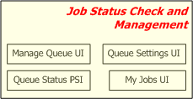

How it all works together
The Project Server Queuing System modules must interact and work as a whole when the system is tasked with requests, such as adding jobs, processing jobs, and retrieving job status.

Adding Jobs
There are many ways in which jobs can be added to the queue. A project manager saving a project from Project professional, a team member submitting a timesheet, a 3rd party application publishing a project – all these call the respective PSIs, which in turn add the appropriate jobs to the queue.
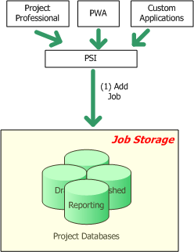

Job Processing
Job processing occurs in different phases and involves interaction between various modules:
- Start Job Polling threads: When the Queue NT Service starts, it starts the job polling threads. The queuing NT service should always be running for the Project Queue to work.
- Pickup new jobs: The polling thread looks for new jobs in the project databases.
- Create job processing threads: If there are new jobs, job processing threads are created.
- Write status: Once the job processing threads complete, the status of the job (success or failure) is written back to the database.
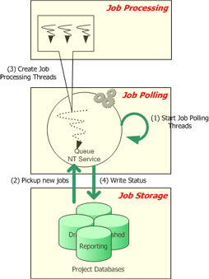

Retrieving Status
Retrieving status: Job status can be checked in multiple ways. Administrators can use the “Manage Queue UI”, Team members can use the “My Jobs UI”, Software Developers can programmatically get status using the Queue PSI methods.

The Project and Timesheet queues
The Office Project Server 2007 Queuing System is composed of two separate queues:
Project Queue Primarily used for project-related messages such as Save, Publish, Reporting, and Cube Building, although sometimes other types of messages may be sent to this queue as well. Its tables and stored procedures are stored in the Office Project Server 2007 Draft database.
Timesheet Queue Primarily used for timesheet-related messages such as Timesheet Save and Timesheet Submit, although sometimes other types of messages may be sent to this queue as well. Its tables and stored procedures are stored in the Office Project Server 2007 Published database.
The design of these two queues are identical to each other, except that their jobs reside in different databases. The advantages in having two types of queues include:
- Performance: Storing queue job data in the same database as the core data saves the queue from making expensive cross-database calls during job processing. Let’s look at an example. When a Timesheet Submit job is submitted, the data entered by the user (for example, hours worked) is packaged as part of the submitted queue job and in put into the SQL job store. Also there is already existing information about a Timesheet (Timesheet duration, name etc), and this information is available in the “Published” Database. For processing the TimeSheet Submit job both these sets of data are necessary. Performance is improved if both these sets of data reside in the same database. Hence the decision to store Timesheet queue jobs in the “Published” database (where all timesheet core data resides) and Project queue jobs in the “Draft” database (where most of the project core data resides).
- Fine-tuning: Every setting in the queue can be specified separately for the Project and Timesheet queues. This gives administrators a lot of flexibility in configuration. For example, if a customer is using Project Server 2007 primarily for timesheets and there are very few projects, they can set the polling interval of the Project Queue to be one minute, and the polling interval of the Timesheet Queue to be 10 seconds.
Note The polling interval setting is used to set the time interval in which the queuing service checks either of the queues for new jobs. This setting can be set in the Project Web Access Queue Settings page.

How the Project and Timesheet Queues are Used
The following graphic showed how the modules in the Project Server Queuing System work with the project and timesheet queues.
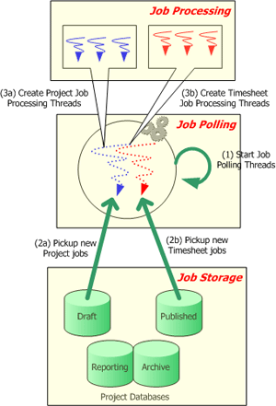
- Job Polling: For every PWA instance serviced by the Queue (the queue can service more than one PWA instances, more on that later), two polling threads are launched – one to service the project queue, another to service the timesheet queue. Both of these reside within the “Queuing NT Service” process space and run under the “Queueing NT service” identity.
- Job Storage: As mentioned above, the project related jobs (Project Save, Publish, Reporting, CubeBuilding etc) are stored in the “Draft” database. The timesheet related jobs (Timesheet save, Timesheet submit etc) are stored in the “Published” database.
- Job processing: There is no change here. As and when the “job polling threads” discover new jobs, new job processing threads are created. Note that the job processing threads still reside within the “Queuing NT Service” process space and run under the “Queueing NT service” identity.
- Job Status Check and Management: There is no change for the status checking modules – they just check for status of a job, they don’t care which queue the job is part of. Queue management is always per queue – in the “Manage Queue” UI, administrators have to select which queue (project or timesheet) they are changing the settings for.
?Top of Page

Queue Deployment
To understand how the Project Server Queuing System is deployed, you need to understand how Office Project Server 2007 is deployed in general. This section provides a brief overview – for details, please refer to the deployment guide.
Even after reading the previous sections, there may be a number of basic questions in the reader’s mind:
- How does the Queue NT service get created in the first place?
- How does the Queue NT Service get started – for example, how does it find the location of the Project draft and published databases.
- What happens on provisioning more than one PWA instance (which creates more Project databases)?
- What happens on provisioning more than one SSP (which creates more Queue NT Services)?
This section addresses these questions.

How the Queue NT Service is deployed during Office Project Server 2007 Installation
To understand how the Project Server Queuing System is deployed, you need to understand how Office Project Server 2007 is deployed in general. This section explains how the Queue NT Service is deployed in context with a brief overview of Office Project Server 2007 deployment.
- Prepare your machines: Determine your physical architecture for your deployment. For this example, we identify two computers for running the Web application (serving Web pages), one computer for the middle tier operations (project save, project publish etc) and one computer for the database.
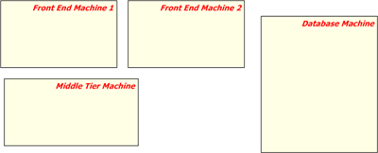
- Create a Project Server Farm: As soon as you try to install Project Server on any of the machines, you will be prompted to create a farm (or join an existing farm). You can roughly think of a Project Server farm as a conceptual representation of your installation – the farm infrastructure takes care of deploying the right things at the right place. Creating a farm also creates a farm Central Admin Web site from which you can control all farm operations from a central location. A farm is characterized by a farm Configuration Database which holds configuration information about all the servers in your farm.
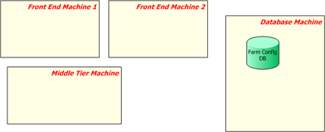
- Install binaries and join farm: The next step is to install Office Project Server 2007 on all the machines and join the project server farm. As part of this process, you get to designate a role for the machine in which you are executing the installation (either ‘Front end’ or ‘Middle Tier).
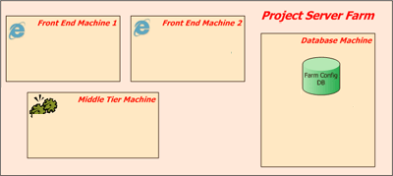
- Provision a Shared Service Provider (SSP): When provisioning an SSP with the Project Server Application Service enabled on the middle-tier, the services/components necessary to ‘service’ a Office Project Server 2007 installation are installed. Among other things, it would create the Queue NT Service, the Events NT Service and the PSI Web application.
  - The farm infrastructure takes care of installing the required components on every middle-tier machine. If there is more than one middle tier server, they automatically share the load.
  - Each of these services runs under the identity of the Shared Service Provider application pool. It cannot be managed manually through the Services option in the Windows Server 2003 Control Panel. Changes to the service account are made automatically by the SharePoint Timer service when the administrator updates the credentials for the application pool account in Central Administration.
The white callout in the diagram below shows the logical configuration of the farm. In this case, a SSP gets created in the farm.
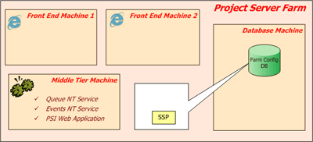
- Provision Project Web Access (PWA): This is done by navigating to the SSP Admin Web site and creating a Project Web Access instance. Once completed, this would create the services/components necessary for a PWA instance. This process creates:
  - A WSS Site collection called Project Web access on the Web application indicated.
  - Four project server databases.
  - Entries in the configuration database that register the relationship between the PWA site and databases.
The Queue NT Service and the Events NT Service are now restarted. On start, they become aware of the new PWA instance and can now facilitate requests that come from the Web Front end.
The white callout in the diagram below shows the logical configuration of the farm. In this case, a new PWA instance (PWA1) gets created in the farm and is linked to the SSP created in the previous step.
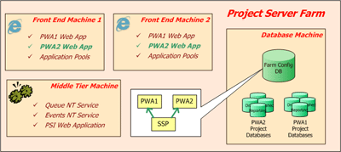
- Provision one more Project Web Access instance (for example, PWA2): It is a very typical customer scenario to create more than one PWA instance in a farm (for example, to service http://project20007/sales and http://project2007/marketing). When this occurs, new sets of Project Server databases are created, as well as more PWA SharePoint site collections.
The white callout in the diagram below shows the logical configuration of the farm. In this case, a new PWA instance (PWA2) gets created in the farm and is linked to the SSP. Note that a new set of Project databases are created for the PWA2 instance.
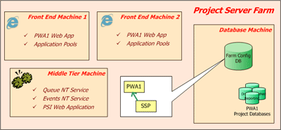

The Queue NT Service on multiple Middle-Tier Machines
The Queue NT Service is created on all Project Server middle tier machines in the farm. For example, if you have two Project Server middle tier machines, as soon as you provision a new SSP in the Project Server farm, a new Queue NT Service will be created on both of these machines. It is important to note that the Queue NT Service services all the PWA instances attached to it's parent SSP.

Queuing Service Properties
As you saw above, the Queue NT Service gets created when a “Shared Service Provider (SSP)” is provisioned in the Project Server Farm. In viewing the properties for the Queuing NT Service Middle-Tier computer, it is important to understand how some of these properties are determined.
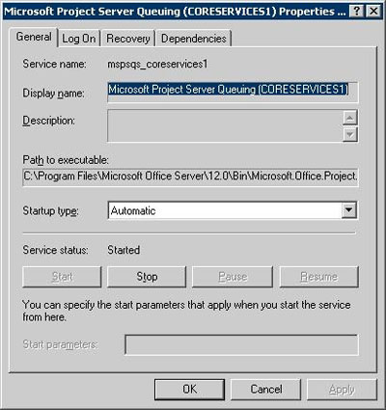
- Queue Service Name: The name of the Queue NT Service = mspsqs_ + name of the SSP. This occurs since there can be more than one SSPs created in the farm (for example, in an out-hosting scenario). On every Project Server middle-tier machine, there will be as many Queue NT Services created as the number of SSPs in the farm.
- Queue Startup Type: Startup type is automatic since the Queue NT Service should always be running.
- Queue SSP ID: The value of the Path to Executable property in the service properties window will contain a path to the queuing executable. For example: <os drive>:\Program Files\Microsoft Office Server\12.0\Bin\Microsoft.Office.Project.Server.Queuing.exe -ssp 5ad80eb9-7f1a-4c34-8198-966d444e972f
The -SSP parameter to Queuing.exe is the GUID of the SSP for which the Queue NT Service was provisioned. This is the key using which the Queue NT Service will discover all the PWA instances that it needs to service.
- Queue NT Service logon account: The Farm Administrator System account is set as the Queue NT Service logon account. This NT account must have read/write access to all the PWA databases that it services (this is automatically done during PWA provisioning).

Queuing Deployment in Various Topologies
This section explains how the queue is deployed in various topologies in which you can have multiple PWA instances as well as multiple Shared Service Providers.

Queue Startup/Servicing with multiple PWAs
When the queue starts up, it first contacts the farm configuration database and asks for all the Project Web Access instances it is supposed to service. The Queue identifies itself using the Shared Service Provider GUID, which is a startup parameter for the Queue NT Service (see Queue Deployment section for more details)
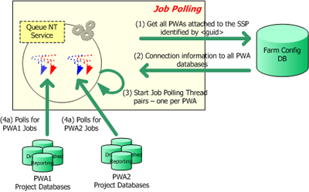
- Queue NT Service contacts the Farm config DB and asks for information about all PWAs attached to the SSP identified by <guid>.
- Farm config DB returns Connection information to all PWA databases.
- Queue NT Service starts Job Polling Thread pairs – one per PWA instance.
- The Polling threads poll for new jobs

Queue deployment in a single-SSP, multi-SSP environment
Here is a representation of the Queue architecture in a single-SSP environment, with two Project Web Access instances provisioned for the SSP.
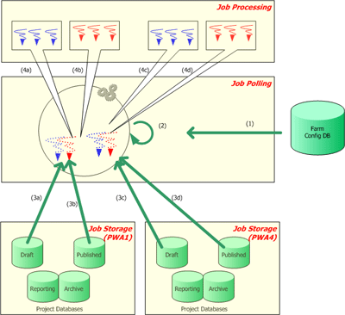
- Getting SSP to PWA mappings from the Project Farm Config database.
- Starting up the job polling threads.
- Job Polling threads polling for new jobs
- As new jobs are discovered, polling threads creating Job Processing threads.

Queue deployment in a Dual SSP environment
Here is a representation of the Queue architecture in a two SSP environment, with a single Project Web Access instance provisioned for each SSP.
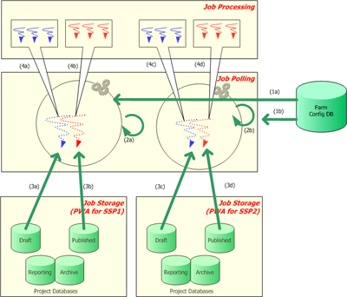
- a: Queue NT Service for SSP1 getting the SSP-PWA mappings for SSP1. b: Queue NT Service for SSP2 getting the SSP-PWA mappings for SSP2
- Queue NT Services start job polling threads
- Job Polling threads polling for new jobs
- As new jobs are discovered, polling threads creating Job Processing threads.

Queue Groupings
There are three distinct levels of grouping for queued data:
Jobs A job is a trackable packet of work that gets executed by Project Server (for example, project save, project publish, timesheet submit). Some jobs are not explicitly initiated by the user (for example, email notifications, Reporting data synch-up). Jobs are the level at which queuing is tracked (using a Job ID).
Correlated Job Group A correlated job group is a categorization of jobs imposed by internal rules of Project Server. Jobs within a correlated job group are always processed together and in order (with some exceptions).
In the example below, Project 1 is edited and saved from Project Professional and then checked in. Project 1 is then checked out by another user, who then publishes it. Publishing Project 1 triggers Reporting and a Reporting job is added to the queue as well.
Project Server assembles a correlation group comprised of the four jobs related to Project 1. It them will attempt to process the jobs in sequence since the Project Server internal rules dictates that is a dependency between the jobs. The dependency that exists is that the Project 1 publish and the Reporting database update cannot occur until Project 1 is saved.
Also, if any of the jobs in the correlation fail, the other jobs after it in the correlation group will be blocked. For example, if the Save Project 1 job (job ID 12) fails, the Checkin Project 1 job (job ID 13) should get blocked. If the Checkin Project 1 job is executed, this will lead to problems. Someone else may then checkout Project 1 (which may be in an inconsistent state due to the failed save) and then attempt to modify it.
Sub-jobs Each job can be broken down further into smaller segments called sub-jobs. If a job is very large (such as saving a 10 MB project) it will be broken into multiple sub-jobs. Sub-jobs are not exposed to the PSI or the Project Web Access user.
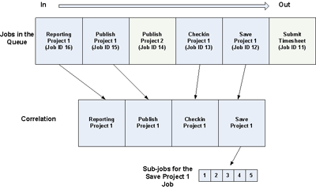
Parent/Child Relationships between submitted Jobs
It is important to realize that parent/child relationships can exist for submitted jobs which require that further processing be done. For example, if a user publishes Project 1, a reporting request for Project 1 will be generated, as well as notification requests regarding Project 1. Note that Notifications Project 1 will always be generated, but since Reporting Project 1 is generated only if Publish Project 1 is successful, should the publish job fail, the Reporting Project 1 job will not be generated.
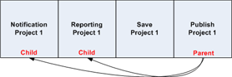
Similarly, a child job may fail without any effect to the parent job. For example, if Notification Project 1 should fail, there will be no effect on Publish Project 1 since it will have already occurred. It is important to note that although the user may be aware that the publish of Project 1 was processed through the queue, he/she may not be aware that a child job may have failed. If you would like to verify what child jobs were spawned from a parent job that they had entered into the queue as well as their status, you can do this through the My Queued Jobs page in Project Web Access. Administrators can use the Queue Management UI and see all jobs in the queue.
Note The My Queued Jobs page and the Queue Management UI is described in the Queue Management section of this article.
?Top of Page

Queuing states
When a job is submitted to the queue it can go through various states. The table below describes each of these states:
State | Description
Getting Queued | Job is put into the queue. A job ID is issued.
Waiting to be Processed | Job is in the queue and is waiting to be processed.
Processing | Job is being processed.
Success | Job has been successfully process. This is a terminating state in which the job can go no further.
Blocked | Job has been blocked by failure of another job before it in the same correlation group. Will retry or will cancel.
Failed and Not Blocking Correlation | Job has failed, but is not blocking any other jobs in it's group. This is a terminating state in which the job can go no further.
Failed and Blocking Correlation | Job has failed and may be blocking one or more dependant jobs.
Skipped for optimization | Job has been skipped because a duplicate job has been found after it within the group. For example, a project manager may attempt the following in sequence when working with a project:  - Saves Project 1  - Publishes Project 1  - Changes a task in Project 1  - Publishes Project 1  - Changes the start date of Project 1  - Publishes Project 1  All three incremental saves to Project 1 will be processed. However, all three publish attempts do not need to be processed. If the last publish job is processed, it would produce the same results as if all three publish jobs were processed. For optimization, the first two publish attempts are skipped.
Cancelled | Job has been cancelled. A job can be cancelled from any state except the two terminating states (Success, Failed and Not Blocking Correlation).

Changes in queue state
As jobs are entered into the queue and processed, it is important to understand the possible changes in queue state that can occur. The following flowchart describes the possible paths through each state.
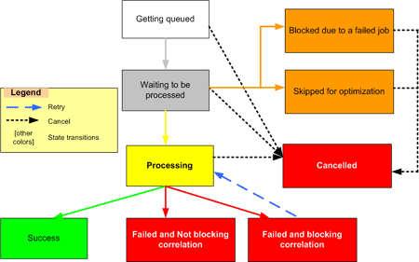
State | Next Possible State | Comments
Getting Queued | - Waiting to be Processed  - Cancelled
Waiting to be Processed | - Processing  - Cancelled  - Blocked  - Skipped for optimization
Processing | - Success  - Failed and Not Blocking Correlation  - Failed and Blocking Correlation  - Skipped for Optimization  - Blocked  - Cancelled
Success | End
Blocked | - Processing  - Cancelled | All Blocked jobs are retried (sent back to Processing) for the allowable number of retries.
Failed and No blocking Correlation | - End  - Processing | If the job is retried, it will go to Processing.
Failed and Blocking Correlation | - End  - Cancelled  - Processing | - Jobs that are dependant on a job in this state will go to Blocked status.  - If the job is retried, it will go to Processing.
Skipped for Optimization | - Cancelled  - Processing | - Jobs that are skipped for optimization have an identical job later in the group sequence (for example, the user saved a job twice by mistake).  - When the identical job is processed, the original job is cancelled.  - If the job is retried, it will go to Processing.
Cancelled | End
?Top of Page

Queue Management
Most of the mission-critical operations in Office Project Server 2007 go through the queue. Therefore, understanding and managing the queue is very critical to the smooth functioning of your Microsoft Office Enterprise Project Management (EPM) Solution installation. For example, the following are relevant topics that may prompt you to manage the queue better:
- My project takes forever to publish.
- The queue management page takes forever to load and the number of jobs says 100,000.
- My manager asks me how to verify that the purchase of a new middle tier Office Project Server 2007 server has in fact improved performance.
Queue management can be executed through the following:
- Queue Management UI
- Self Management UI
- Performance counters
- Queue Cleanup Project Resource Kit (PRK) tool

Queue Management UI
Queue management can be done through the Manage Queue settings in Office Project Web Access. This is similar to the central “show all jobs” UI in any common printer from which you can see all the jobs in the queue and resolve issues if necessary.
From the Manage Queue page you can:
- See the status of all jobs in the queue.
- Cancel or retry a job if it has failed.
Note See state management section for more details about queue states.
Note To view user interface information on queue management, please go to the Administering the queue section of this article.

Self Management UI
The My Queued Jobs page provides a self management user interface - similar to the “Print spooler” on any individual PC – from which you can see the status of your own specific jobs that you had entered into the queue.
If a user would like to view information on all jobs that they had entered into the queue, they can do this by going to the My Queued Jobs page in Project Web Access. The My Queued Jobs page displays the following information on jobs the user entered into the queue:
- Queue Entry Time
- Queue Completed Time
- Job name
- Job type
- Job state
- Percent complete
- Queue position
- Queue type
- Error
Additionally the My Queued Jobs page allows a user to filter all their queued jobs based on:
- In progress and failed jobs
- All jobs
- All jobs in the last week
- Successful jobs in the last week

Performance counters
There are many performance counters that are specific to queuing that administrators can use to benchmark your current Project 12 system performance. These performance counters can be very helpful in determining if your current configuration meets your goals or if you need to justify additional resources, such as another server.
Some of the counters that are available pertain specifically to jobs, such as:
- Average wait time for any job in queue
- Average processing time for Publish jobs
- Percent of jobs failed
- Average wait time
Other counters pertain to the queue in general, such as:
- Average queue depth
- % of SQL Retries
- SQL Calls per hour
- Average processing time for Publish jobs

Queue Cleanup Project Resource Kit (PRK) tool
The Queue Cleanup tool is part of the Project Resource Kit and allows you to delete or archive job status entries that are no longer needed. As jobs enter into and are processed through the Office Project Server 2007 Queuing System, job status entries for each are entered into the archive tables. Depending on usage, these have the potential to grow very large and may potentially affect system performance. A utility such as the Queue Cleanup PRK tool can be used to keep this potential problem under control.
Note More information on the Queue Cleanup PRK tool will be available after Beta 2.

Queue Maintenance after Migration
Migration from a previous version of Project Server to Office Project Server 2007 may create an issue if many projects are migrated. Migration of projects to Office Project Server 2007 will take projects from the previous version and will attempt to save or save and publish them to Office Project Server 2007. Each save and publish action will enter as a job in the queue and will all display in the Queue Management UI job grid. A large number of migrated projects will cause long delay for the job grid to even appear, and will possibly timeout.
It is suggested that after migration to Office Project Server 2007 in which many jobs were migrated, you use the following SQL Script to delete archived migration entries from the draft and publish database:
use <draft database> delete from dbo.MSP_QUEUE_PROJECT_GROUP_ARCHIVE where grp_queue_state = 4
use <published database> delete from dbo.MSP_QUEUE_TIMESHEET_GROUP_ARCHIVE where grp_queue_state = 4
This will remove archived successful jobs from the draft and published databases.
?Top of Page

Administering the Queue
Queue management and administration can be done through the Project Web Access Server Settings page. In the Queue section of the Server Settings page there are two options to administer the queue.
Manage Queue You can view jobs in the queue using this page. You can use the configuration options to filter jobs and only see the jobs you are interesting in viewing. You can also retry or cancel one or more jobs through this page.
Queue Settings You can set configuration options that control the way by which jobs are pulled from the Project and Timesheet queues and processed. These settings get applied without the need to restart the queue service.

Manage Queue
This section describes the queue filtering options are available by selecting Manage Queue in the Queue section of the Project Web Access Server Settings page. The results of the selected queuing options will display on this page as well.

Choose Filter Type
This filter determines the order in which jobs display in the Job Grid section. The available options are:
- By Status
- By Jobs
- By Projects
- By ID
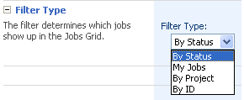

Length of History
This is a history parameter you can add to the queue status request. You have the option to select either:
- Enter the number of days, and then enter a number. This allows you to view the history of jobs entered into the queue for a specific number of days before the present. or to view all jobs that meet criteria.
Note If the Manage Queue page takes a long time to load, you may want to reduce the Enter the number of days field to a smaller number.
- View all jobs that meet criteria. This allows you to view the history of jobs that meet specific criteria that you specify in the Choose Job Type and Choose Job Completion States sections that follow. If this option is not selected, the information in both of those sections is ignored.
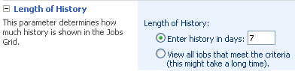

Choose Job Type
This section enables you to select the job types you want to appear in the results.
Note As mentioned previously, this section will be ignored if you choose to view job history based on number of days versus criteria in the Length of History section.
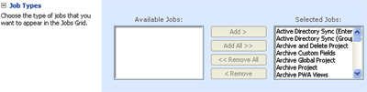

Choose Job Completion States
This section enables you to select the job completion states you want to appear in the results.
Note As mentioned previously, this section will be ignored if you choose to view job history based on number of days versus criteria in the Length of History section.


Choose Columns
This section enables you to select the columns that will appear in the Jobs Grid section.
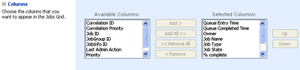

Advanced Options
This section enables you to specify special operations that apply to a cancel operation. The options enable you to:
- Cancel Jobs Getting Enqueued
- Cancel Subsequent Jobs in the Correlation
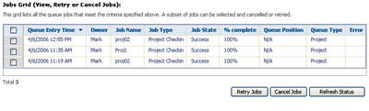

Job Grid
This section enables you to view the jobs that meet the criteria listed in the Manage Queue page. Options within this section enable you to select a job or group of jobs and to apply the following options to them, if applicable:
- Retry Job
- Cancel Job
Note You must manually refresh the View/Select job list to update the page. You can do this through the Refresh button that is available in this section.
?Top of Page

Queue Settings
This section describes the queue configuration options are available by selecting Queue Settings in the Queue section of the Project Web Access Server Settings page.
It is important to note the following when configuring queue settings:
- Queue settings are configured per Project Server instance.
- Queue settings are configured separately per queue type
- The Queuing NT Service does not need to restart in order for changes to take affect.
- If more then one Queue NT Service is services this Project Web Access (such as in a load balanced environment), all the queue services would refresh the settings.
Note After selecting your configuration options on this page, make sure to use the Save Configuration button on this page saves your configuration settings.

Queue Type
This section enables you to specify which queue type (Project or Timesheet) to which you want the setting to apply.
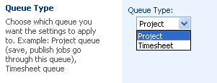

Maximum Number of Job Processor Threads
This section enables you to specify the maximum number of job processor threads that can run at the same time.
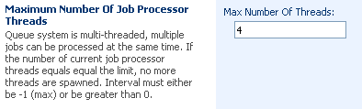

Polling Interval
This section enables you to specify the time interval (in milliseconds) in which the queuing service polls the project or timesheet database for new jobs. The default value is 1000.
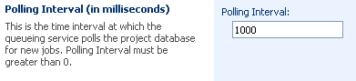

Sub-Job Retry Limit
This section allows you to set the limit of processing retries for a sub-job that fails due to SQL related issues, such as an SQL deadlock. It is important to distinguish this between jobs that are failed for other reasons such as failures that occur during processing attempts in the queuing system.
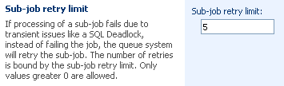

SQL Retry Interval
This section allows you to set the length of time between retries for jobs that have failed through SQL-related issues, as noted previously.
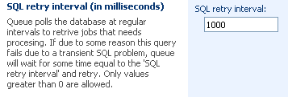

SQL Retry Limit
This section allows you to set the limit on retries on a failed polling query. The Project Server Queuing System polls the databases on a regular basis to retrieve jobs that need processing. If this query should failed for an SQL-related reason, the system will attempt to poll the database again after a period of time.
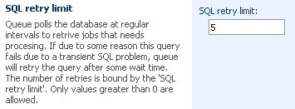
?Top of Page

The information contained in this document represents the current view of Microsoft Corporation on the issues discussed as of the date of publication. Because Microsoft must respond to changing market conditions, it should not be interpreted to be a commitment on the part of Microsoft, and Microsoft cannot guarantee the accuracy of any information presented after the date of publication.
This White Paper is for informational purposes only. MICROSOFT MAKES NO WARRANTIES, EXPRESS, IMPLIED OR STATUTORY, AS TO THE INFORMATION IN THIS DOCUMENT.
Complying with all applicable copyright laws is the responsibility of the user. Without limiting the rights under copyright, no part of this document may be reproduced, stored in or introduced into a retrieval system, or transmitted in any form or by any means (electronic, mechanical, photocopying, recording, or otherwise), or for any purpose, without the express written permission of Microsoft Corporation.
Microsoft may have patents, patent applications, trademarks, copyrights, or other intellectual property rights covering subject matter in this document. Except as expressly provided in any written license agreement from Microsoft, the furnishing of this document does not give you any license to these patents, trademarks, copyrights, or other intellectual property.
Unless otherwise noted, the example companies, organizations, products, domain names, e-mail addresses, logos, people, places, and events depicted herein are fictitious, and no association with any real company, organization, product, domain name, e-mail address, logo, person, place, or event is intended or should be inferred.
Microsoft, Excel, FrontPage, InfoPath, Outlook, PowerPoint, SharePoint, Visio, Windows, Windows Server, and Windows Server System are either registered trademarks or trademarks of Microsoft Corporation in the United States and/or other countries.
All other trademarks are property of their respective owners.
? 2005 Microsoft Corporation. All rights reserved.

